NAME | REG ID
NAIM UL ABD | 240009
USMAN NAZIR | 240025

Planning Our Portfolio Website
This is a great start to planning my portfolio website.Here is a breakdown of the tasks that are involved in planning phase
Task 1: Define Your Purpose and Audience
Purpose:
- Digitalizing our resturant: My main focus is to provide ease to our customers so that they can get their favorite food at home and make our business on the large scale.
Target Audience:
- We focuses on the public that what they want to eat and what’s the taste they want because some people wants to eat Italian, some want Chinese, and some want traditional food, so that’s why we can focuses the customers’ taste.
Task 2: Sketch Your Website Layout on Figma
Figma:
Figma is a great tool for creating wireframes and prototypes to visualize your website's structure and functionality. Here are some points to consider for my Figma designs.
Layout:
- Sections: Consider including the following sections:
- Home: A captivating introduction with your name, a brief bio, and a call to action (e.g., contact you).

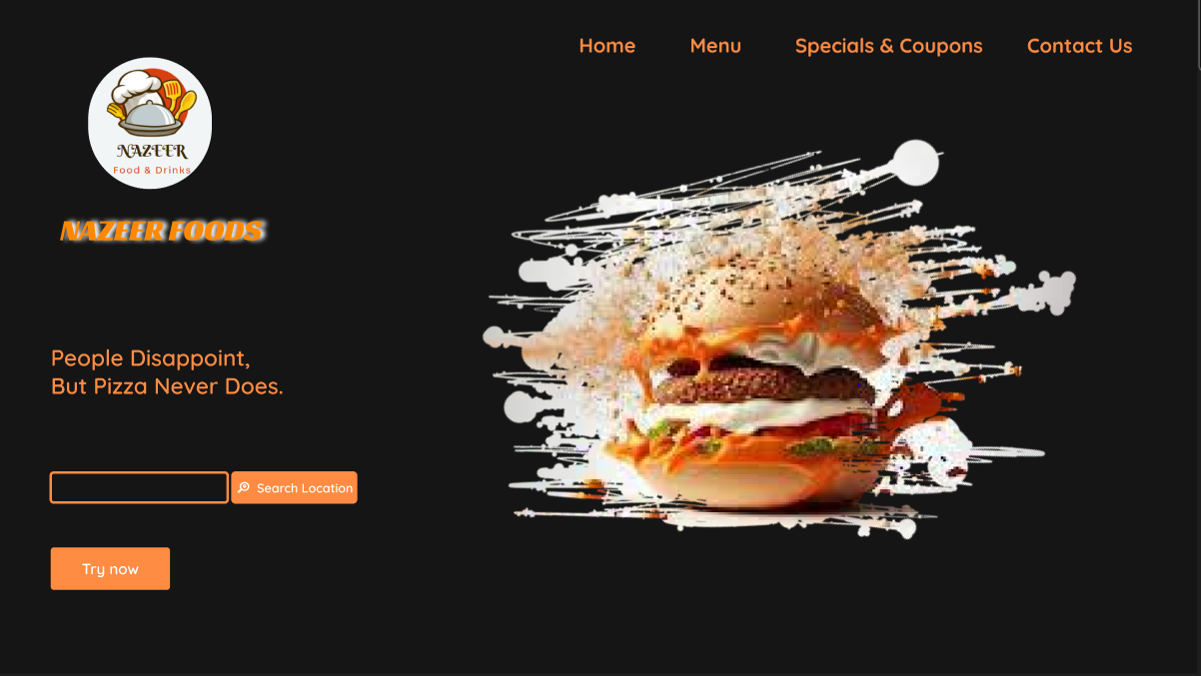
ABOUT US:
"Here, at NAZIR FOODS, we understand cravings. We know how important it is to get your food fast, and we have a 1-hour delivery guarantee, or you get your money back. We believe the best dishes are the ones that remind you of childhood.
While we prepare our food fast, we develop the flavor slowly. Our dough rises over the night, and our meat is always marinated. That's why every chicken tender, every beef skewer, and every bun taste like heaven.
Our menu is seasonal. Today, we may serve you chicken corn soup, and tomorrow we may have a classic Kulfa falooda on the menu. But the taste is always the same: finger-licking good!
Don't hesitate to pay us a visit if you share our passion for fresh dishes cooked with only the best ingredients. We promise an experience that will keep you coming back for more!”

MENU: Here is our delicious menu for you.

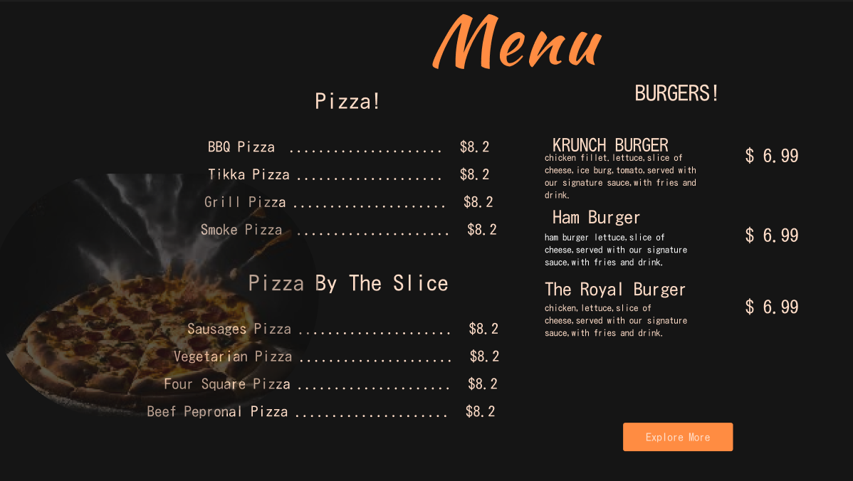
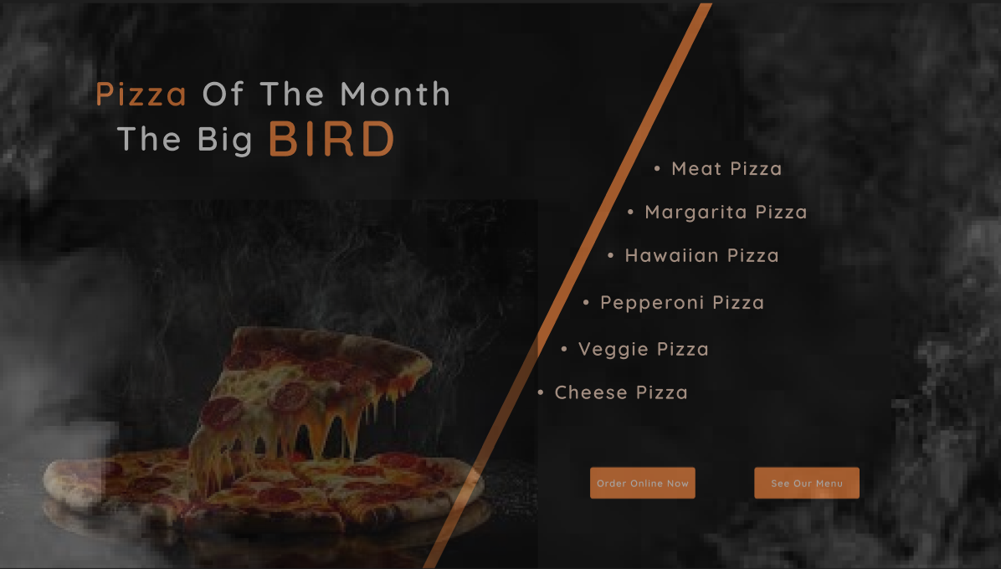
ONLINE BOOKING: We can facilitate you with our online reservations.
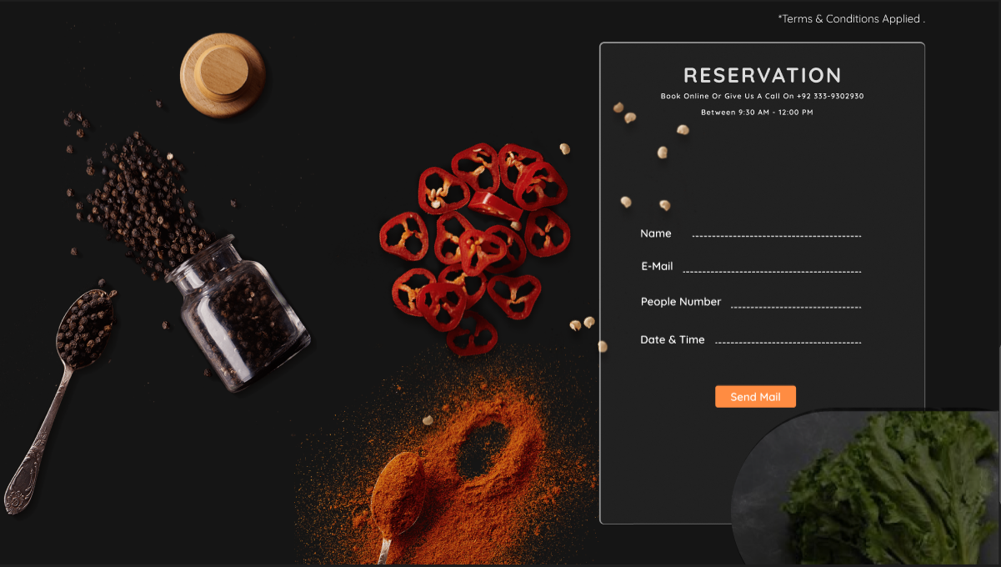

ONLINE ORDERS: Now you don’t have to come at our place, because we can deliver your order at your doorstep.
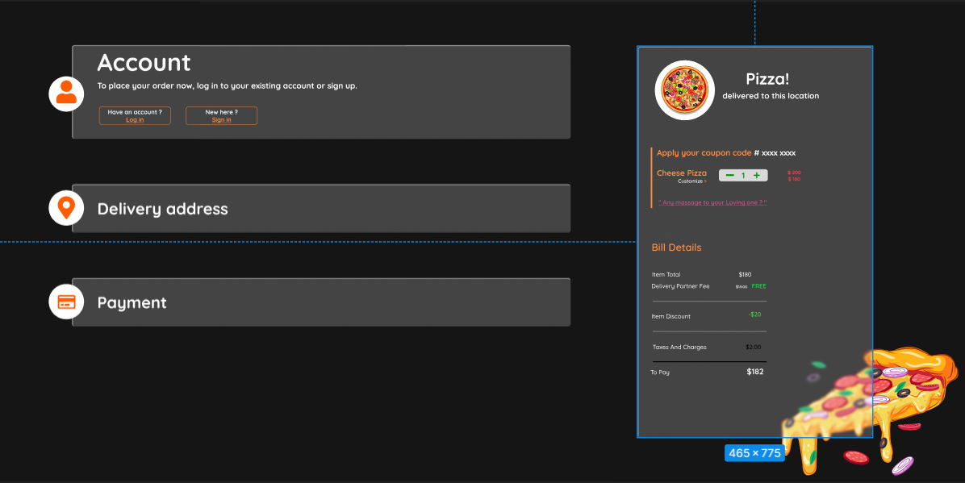
Design:
- Color Scheme: This website contains the contrasted colors of black and mustard color
- Aesthetics: We mainly focus on user friendly and visually appealing website that attract user and don’t really irritate them.
Additional Tips:
- Mobile Responsiveness: My website looks good and functions flawlessly on all screen sizes (desktop, mobile, tablet).
- Content: Focus on high-quality food.

FIGMA LINK

- Pizza website (Community) – Figma

